IOT BASED NOISE MONITORING SYSTEM

A Project report submitted in partial fulfilment of the requirements for the degree of B.E in Computer Science Engineering

By

J.NETHAJI (513221104017)

Under the supervision of Professor & HOD Department of Computer Science And Engineering Development of Noise Monitoring Network in India

With increasing urbanization and industrialization, noise pollution particularly in ambient is also increasing. Government of India have taken number of steps to control noise pollution such as notifying noise rules-2009 and prescribing noise standards for vehicles, generators sets, fire crackers etc. Till now Maharashtra Pollution Control Board is carrying out noise monitoring in urban area during festival periods (Diwali and Ganapati) and ambient noise monitoring in 6 major cities of Maharashtra is being carried out once in a year at fixed locations and the reports of these monitoring are being displayed in the public domain through MPCB web site.

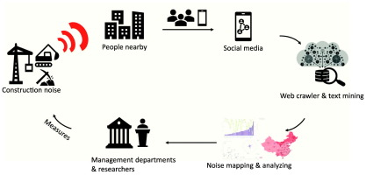

The Honourable Minister of Environment and forest has announced the road amp of systematic monitoring of ambient noise under the National Ambient Noise Monitoring Network Programme (NANMP) in the month of January, 2010. As per the proposed road map 10 continuous monitoring stations are to be established in each of seven identified cities .

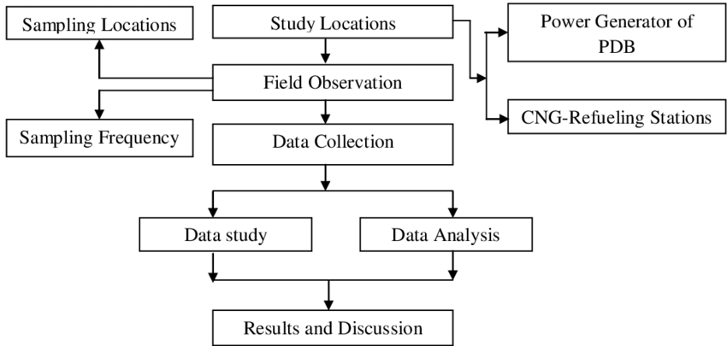



Mumbai, Delhi, Kolkata, Bangalore, Chennai, Lucknow and Hydra bad. Out of 10 stations proposed in Mumbai, 5 continuous monitoring stations have been installed at Mumbai/Navi Mumbai/Thane area at following locations: 1. Bandra, 2. Wadala, 3.Mahape (Navi Mumbai), 4. Vashi (Navi Mumbai) and 5. Thane Municipal Corporation Building (Thane). These above stations are in networking and real time noise data is being transmitted to the central server at CPCB. Glimpse of Noise Monitoring Stations

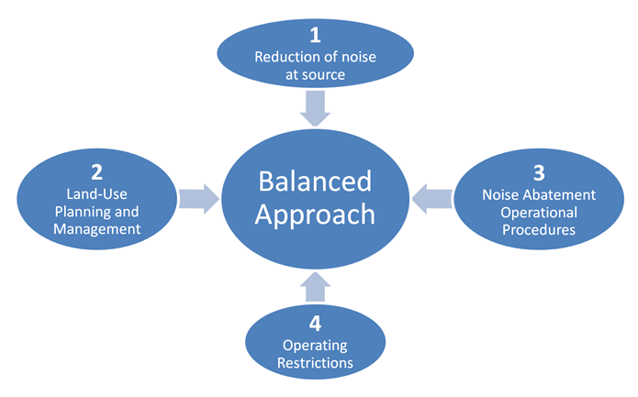

Import sounddevice as sd

Import numpy as np

Def audio_callback(indata,frames. Time,status):

If status:

Print(status,flush=True)

If np.max(indata)> 0.1: #Adjust this threshold as needed print(“Noise deleted!”)

With sd.inputstream(callbackaudio_callback):

Sd.sleep(10000) #run the program for 10 seconds

Print(“program ended.”)

